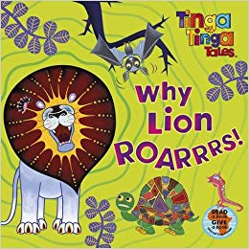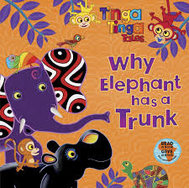

Similarities | Differences
Which was your favourite story and why?

