Children’s Art Week: egg box art!
This week, it is Children’s Art Week and we would like you to get creative with egg boxes. Cardboard egg boxes are easier to work with and we hope you have one or two empty ones in your house or recycling box. These ‘eggscellent’ websites have over 50 different ideas for egg box craft projects. Perhaps you could make a selection of egg box bugs. Or how about the wonderful masquerade masks?
https://feltmagnet.com/crafts/how-to-make-egg-carton-crafts
https://www.thesprucecrafts.com/egg-carton-kids-crafts-4129406
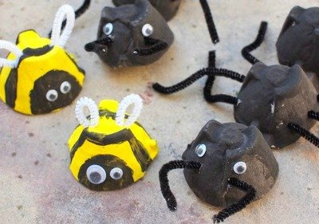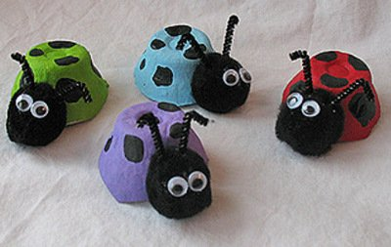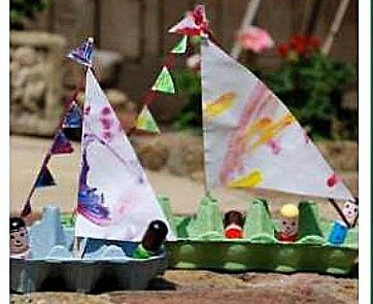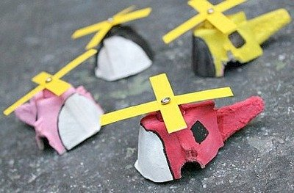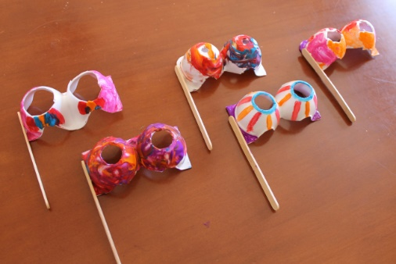

If you haven’t got an egg box, you could try creating something with a cardboard tube (kitchen roll and toilet roll tubes work well or you could make your own tube with a piece of card). Find some inspiration here:
https://fabulesslyfrugal.com/diy/toilet-paper-roll-crafts/

Look at this fabulous website and find out how to make a shadow theatre from toilet rolls:
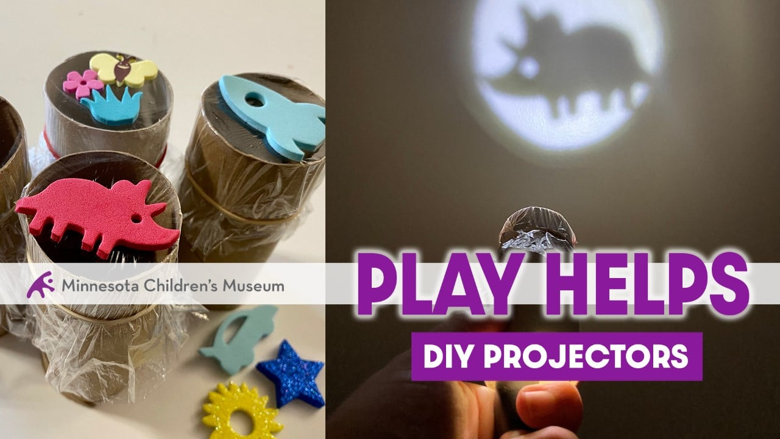
https://mcm.org/make-your-own-projectors/

Make sure you email us with all of your brilliant creations ☺

