WALT partition numbers to 100
- Read and write the number

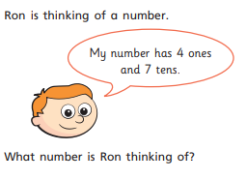

- Can you draw the dienes in the place value charts?
- 57 67 77
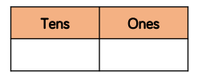
- 71 72 73

- 91 19

- Can you draw lines to match the values to the pictures?

