WALT make and count groups of 2
- Can you use pairs to make the groups of 2?

1 group of 2 = 2 groups of 2 =

3 groups of 2 = 4 groups of 2 =

- Can you coung the groups of 2?



___ groups of 2 =



___ groups of 2 =

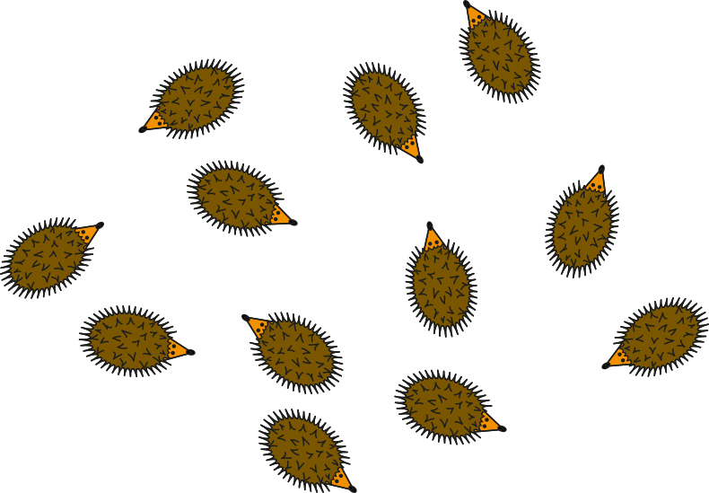
___ groups of 2 =

- Can you draw the groups of 2?
16 = ____ groups of 2
18 = ____ groups of 2

Teacher challenge
