WALT find half of a quantity.
- Find half of these shapes.

- Using the bar model below, find half of these quantities.

Half of 2 =
Half of 4 =
Half of 6 =
Half of 8 =

- Which of these representations show half of ten?
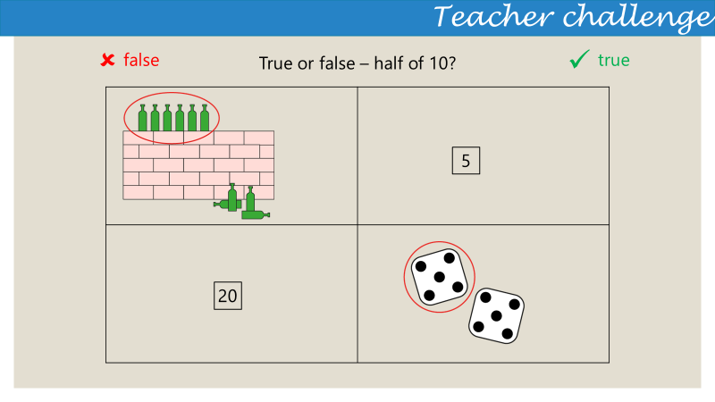

Cut out these pictures and use the bar model to find half of the quantities.

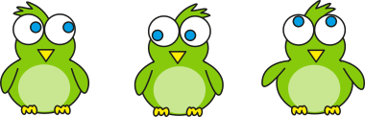

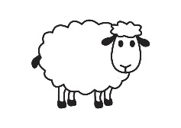

part
part
Whole

