Time Capsule Challenge

What will you remember most about Lockdown? Not being able to see family and friends? Not attending school? Clapping for Carers every Thursday evening? The quiet roads? Going on your daily walk?
This week, we would like you to put all of your Lockdown memories in one place and make a time capsule to remember this historical event.
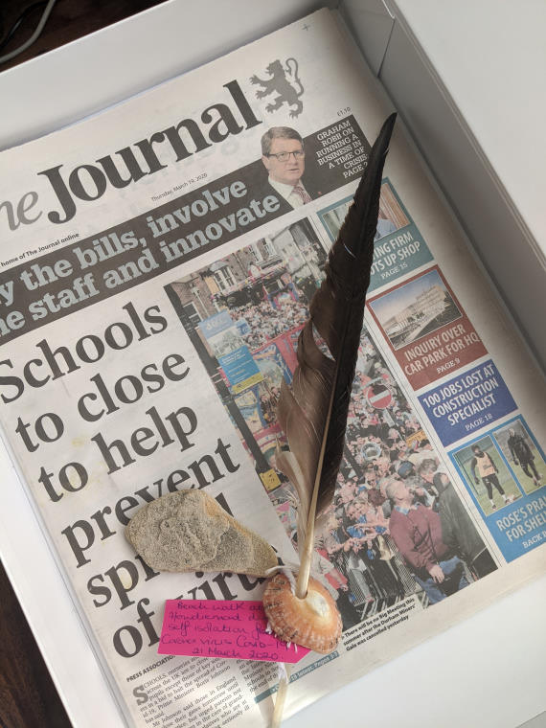
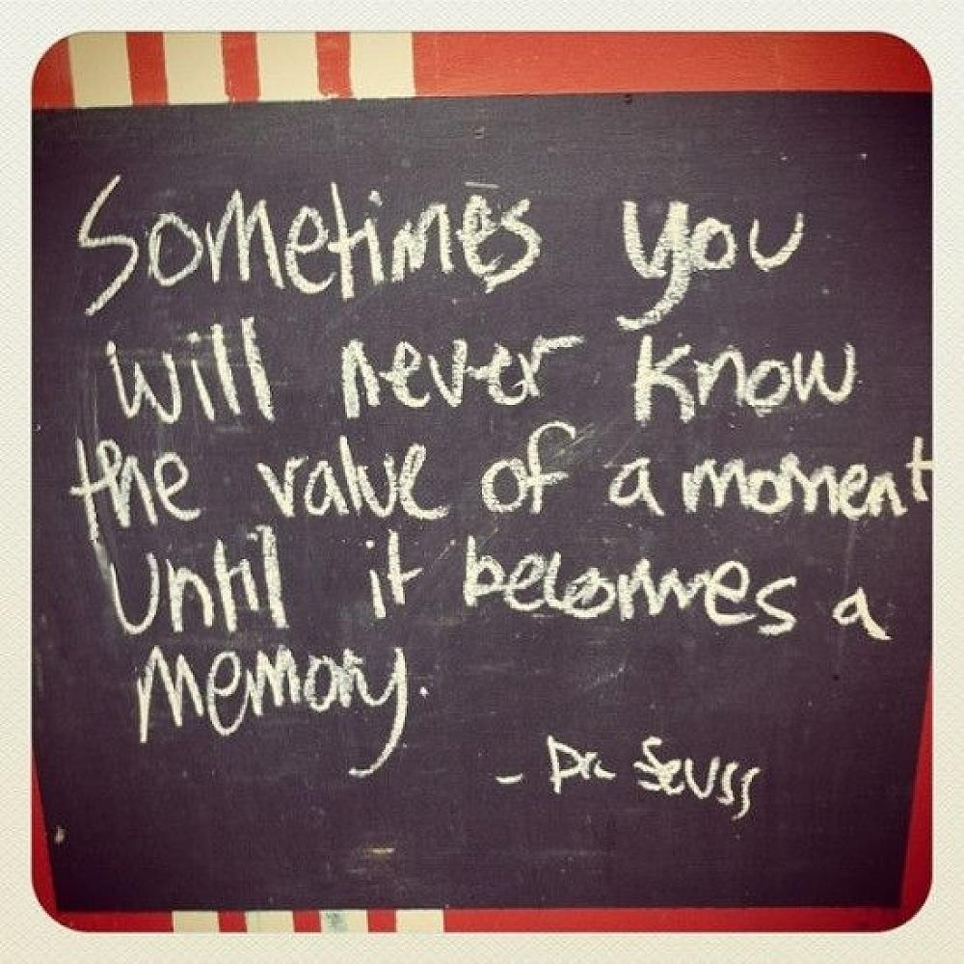

This website is a good place to start if you need some ideas of what to include:
https://kidsofthewild.co.uk/2020/03/29/make-a-time-capsule-coronavirus-covid-19-kids/

There is also a checklist on the next page to help you but you can put in whatever you like – whatever reminds you of this time. Your capsule doesn’t have to be big. You could use a jar and fold everything up nice and small to be discovered some time in the future. Have a great time and don’t forget to email your time capsule photos to the home learning email addresses.

