WALT count multiples of values.

1. Count the multiples of coins to find the total value

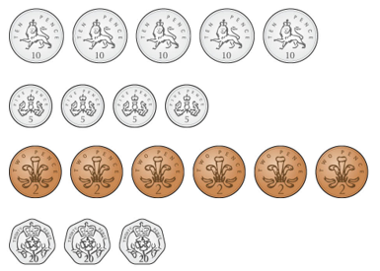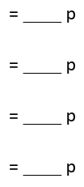

1. Which value is **greater**? Circle your answer

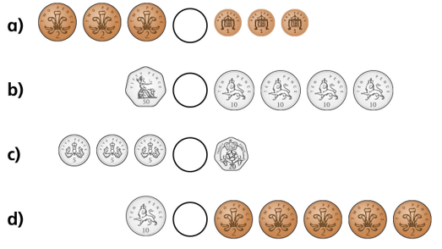

or

or

or

or

1. How many more? Draw the coins needed to equal the same amount.



=





=



=

