Quiz Master Challenge!

If you’ve been keeping an eye on the website every Friday, you might have been enjoying the quizzes set by Mr Robins. There’s been a logos quiz, a musical intros quiz and a spot the difference quiz. Some of the schools did a ‘teachers in their childhood days’ photo quiz - did you manage to guess any? You and your family may have been spending some time doing family quizzes on Zoom – it’s certainly been a feature of lockdown in lots of the teachers’ houses. Now it’s over to you!
This week’s challenge is to create a quiz. You could keep it simple and write ten questions on a topic of your choice or you could create a photo quiz to see if your friends and family can guess the item or character from a photo showing only a small part of it. You could write a ‘What am I?’ quiz – write 3 clues and see who can guess what or who you are.

Here are a few ideas to get you thinking:
Name it:
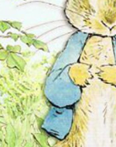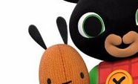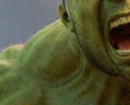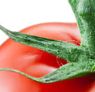

What am I?
I live in the ocean. I have 8 tentacles. I have three hearts. What am I?

What links…
What links Hobnob, Digestive and Bourbon? (answer: all types of biscuit)
What links Trafalgar Square, Buckingham Palace and Big Ben? (answer: all London landmarks)

Ms Sampson absolutely loves quizzes and is our official Pegasus Academy Trust Quizmaster – perhaps she will use one of your excellent creations for her next quiz meeting. Don’t forget to email them to your home learning email address or post them on your blog.
Happy quizzing

