Label the different ways that land has been used in Thornton Heath

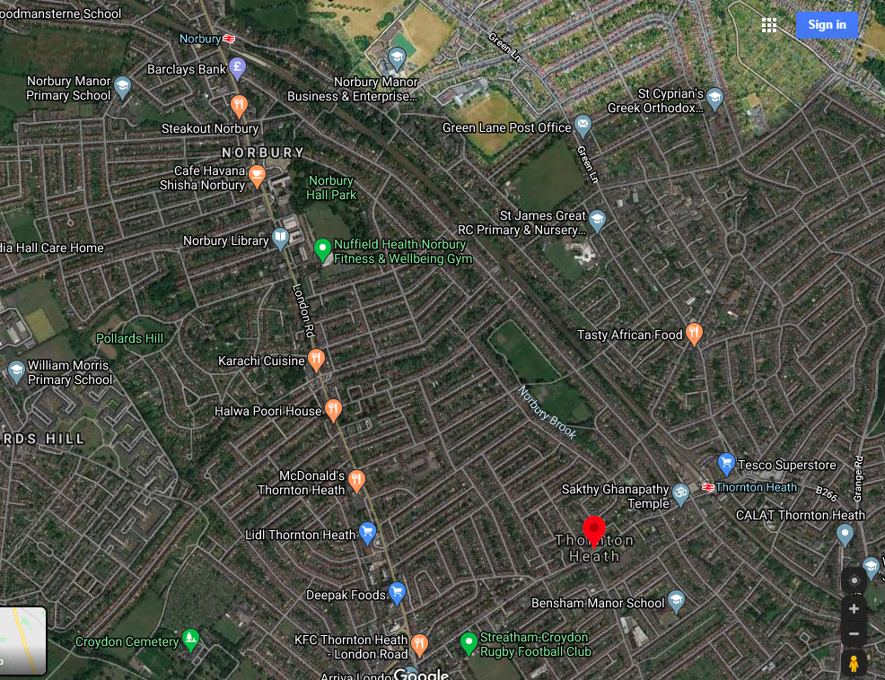

Retail Housing Factories and business Leisure Transport Agriculture Schools

Which land use was the most common? Why do you think this is?

_____________________________________________________________________________________________

Which land uses were not present in this area? Why do you think this was?

_____________________________________________________________________________________________
_____________________________________________________________________________________________

Did you notice any patterns? What does this tell us about who lives in this area?

____________________________________________________________________________________________
____________________________________________________________________________________________
_______________________________________________________________________________________

Extension: Label the different ways that the land has been used in Scunthorpe. What are the similarities and differences between how the land has been used in Scunthorpe and Thornton Heath?

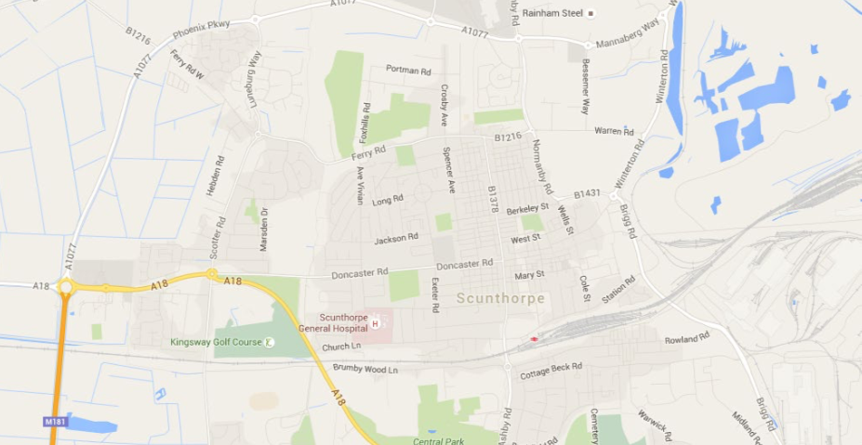

Similarities

____________________________________________________________________________________________________________________________________________________________________________________________________________________________________________________________________________________________________________________________________________________________________________________________________________________________

Differences

____________________________________________________________________________________________________________________________________________________________________________________________________________________________________________________________________________________________________________________________________________________________________________________________________________________________

