How to sign into Google and access a Google Meet
You will need to have Google Chrome – if you don’t, you can download it here: https://www.google.com/chrome/
- Open Google Chrome and check if anyone else if logged in. You can do this by looking at the round icon in the top right corner of the screen. If no-one is logged into Google Chrome, this icon will be the head and shoulders of a person (see the green tick).
If someone is logged in then this icon will be a letter (see the red cross). If this is the case, please go to page 2 for instructions on how to log them out before you log yourself in.
A. X
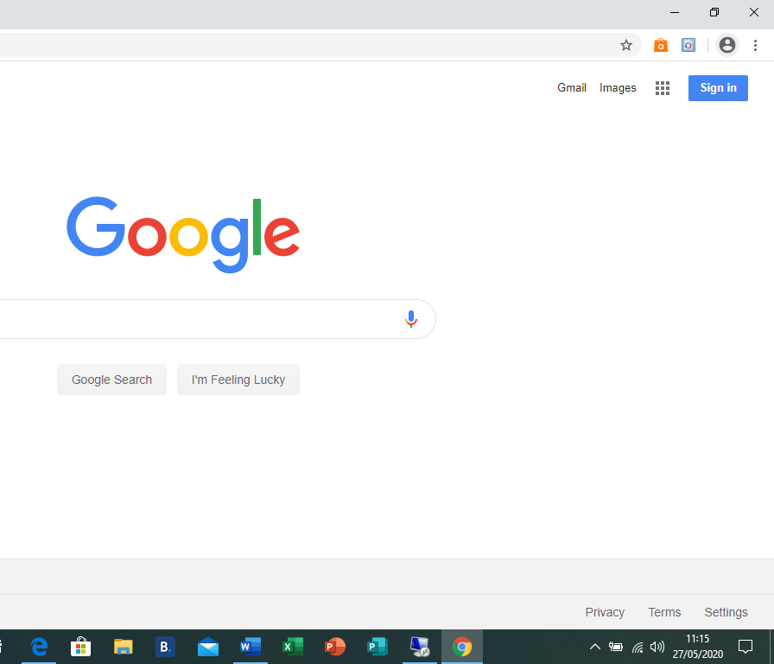
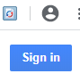
- If no-one is logged in, as per point 1 above, you can now click on the blue button that says Sign in. this is directly below the round icon with the heads and shoulders in the top right of the screen.

- Clicking on the Sign in button will open another window that looks like the image below. In the box where it asks for your Email or phone, you will need to enter your USO username (this is the username you use to log onto the computers at school – it will end in .306) followed by @gsuite.pegasusacademytrust.org (see the example below). Make sure you type this in accurately. Then click Next. You will be taken to the next page where you will be asked to enter your password. This will be the normal password that you use with you .306 password. If you cannot remember these details, please contact your teacher either through you class blog or by emailing yr6@pegasusacademytrust.org.
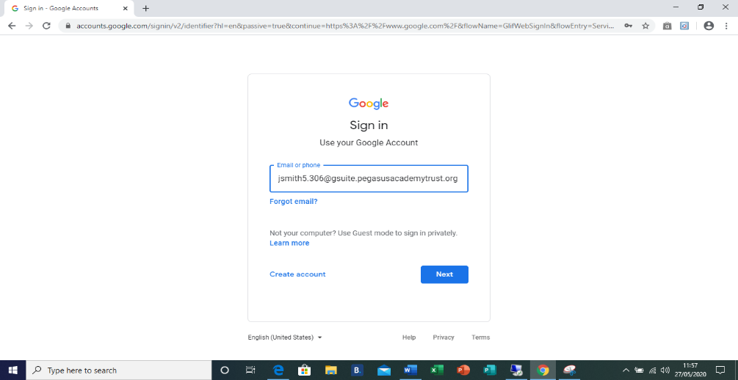

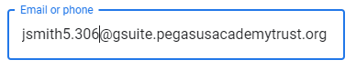

- You can now use the nickname that your teacher will provide on the blog to access the meeting on Google Meet – see How to access a Google Meet instructions below.

Any problems please contact your class teacher via the blog or by emailing yr6@pegasusacademytrust.org.
How to Log Out of Google Chrome

- When you open Google Chrome, if somebody is already logged in the round icon in the top right of the screen will be a letter.

- You will need to click on the letter which will open a screen that looks like this:

You can now click on Sign out.

Once you have signed out, the round icon at the top right of the screen will change to the head and shoulders of a person. You can now start logging in as per the instruction 1 – 4 above,

How to access a Google Meet
- Once signed into Google using the steps above, you can open Google Meet by using this link:
https://meet.google.com/

Your teacher will have shared this link on your blog.

- To join a meeting, click on
+ Join or start a meeting.

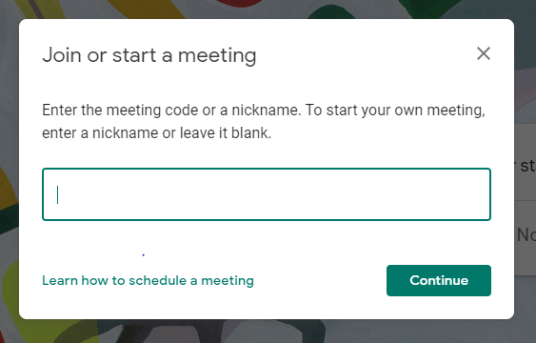
- You will now be asked to enter a nickname for the meeting that you are joining. Your teacher will have shared this nickname with you on your class blog.
Once you have typed the nickname, click enter.

- You should now be able to see yourself on the screen next to a green button saying Join now. Click this button and you will be taken into the meeting.
