How to add a photo to your class blog and share your learning with your classmates!
- Take a photo of your home learning
- Save your photo on to the ‘Picture’s folder’ on your PC or photos in your phone.
- Type Pegasus Academy Trust into the Google search box then …

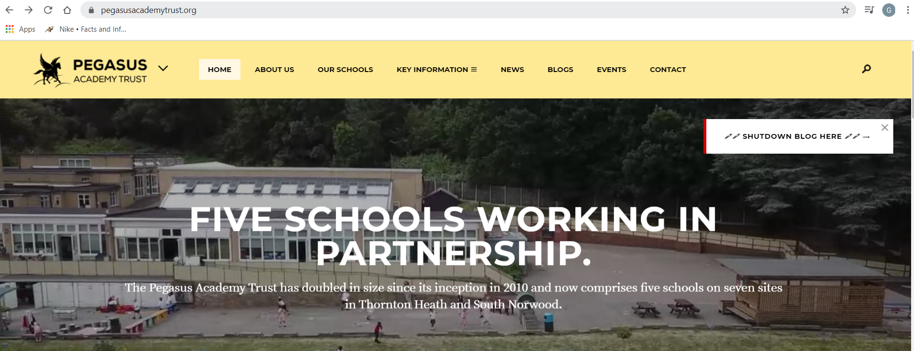
4. Click on ‘Blogs’ on the top menu
5. Click on your primary school and click on your class name
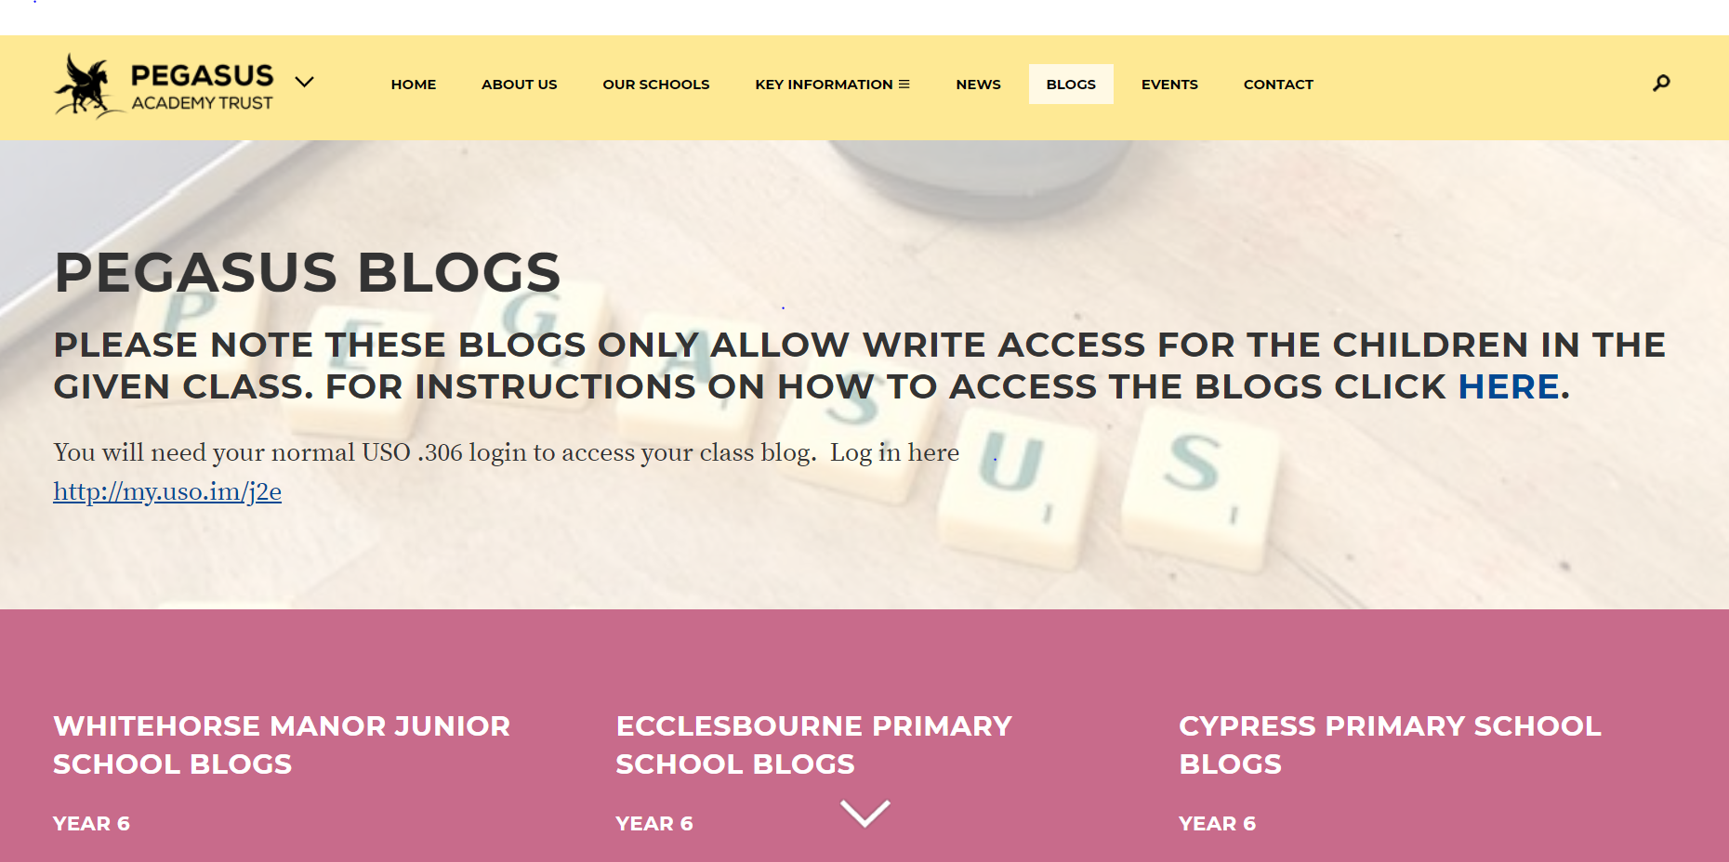
6. Use your (child’s) USO login using the .306 name and password (the same as is used for the computers at school)
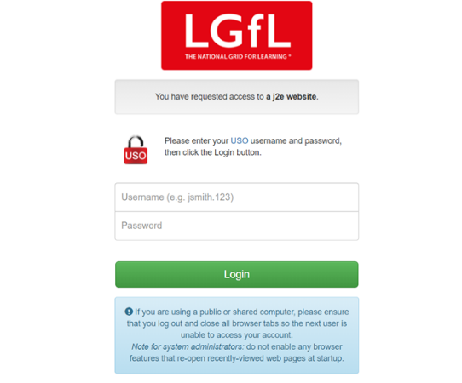

7. Type your school name, select your class name from the drop down menu …and you are in!
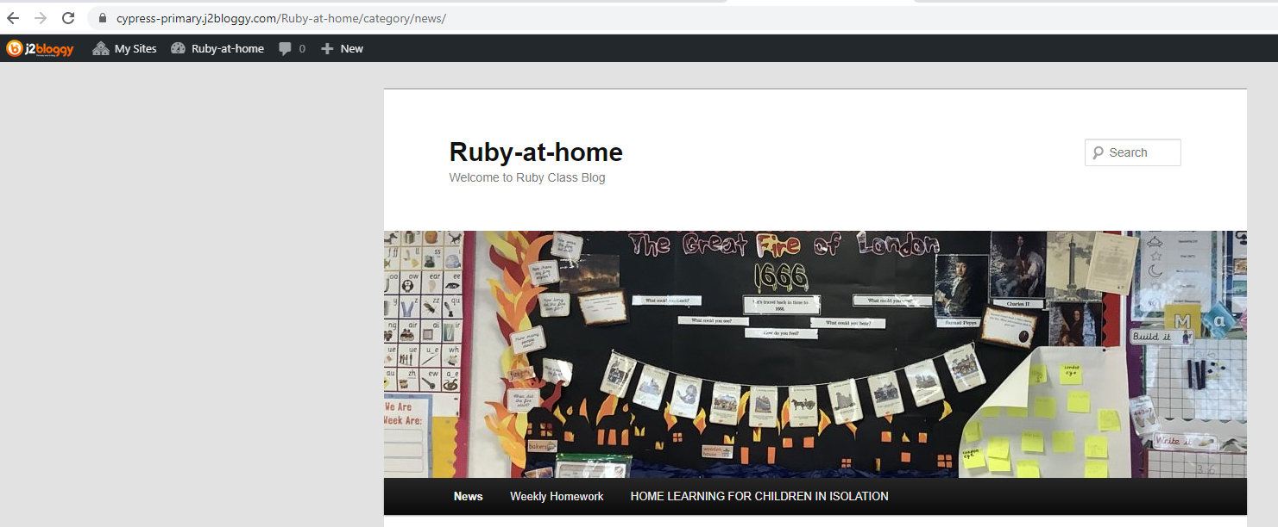
8. Click on ‘+ Post’ (add post)

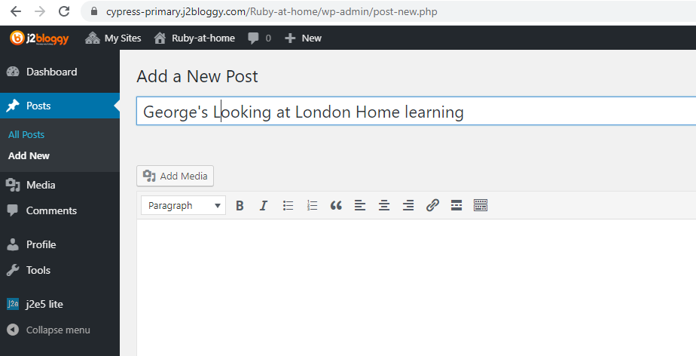
9. Add your name and title of your learning
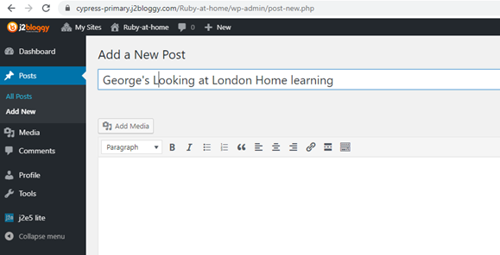
10. Click on ‘Add Media’
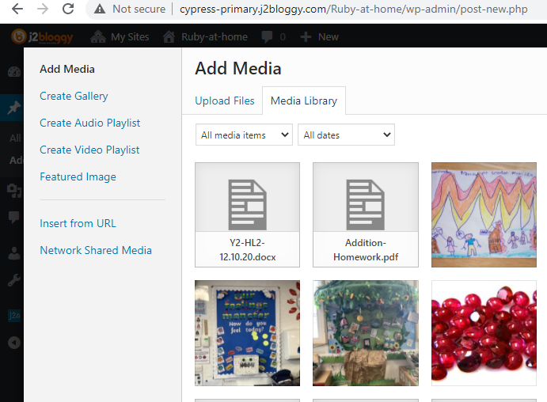
11. Select ‘upload files’ and add your photo from wherever you saved it earlier
12. When your photo is shown in the list highlight it and click ‘Insert into Post’ (bottom right hand corner)
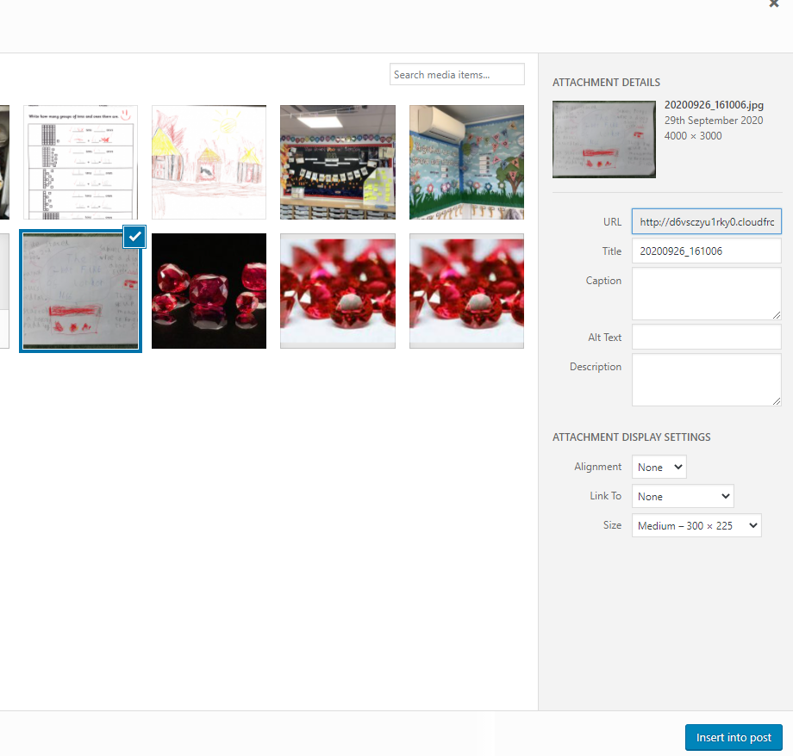
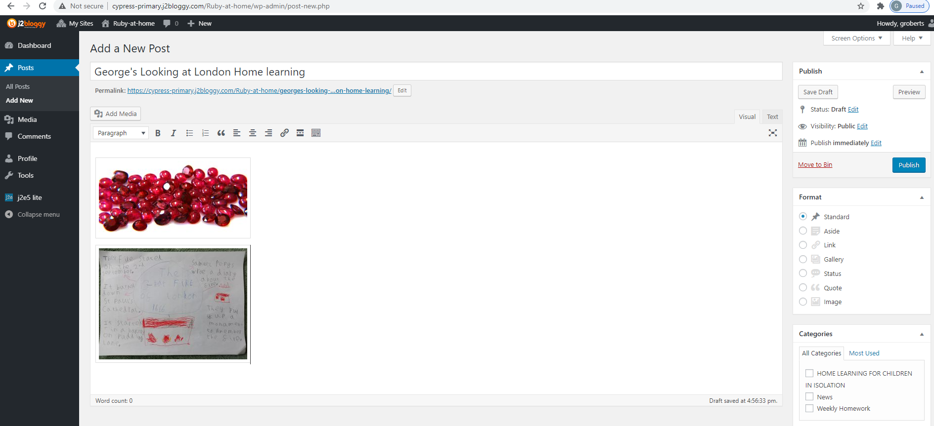
13. Don’t forget to click on ‘Publish’ so that everyone in the class can see your post!

