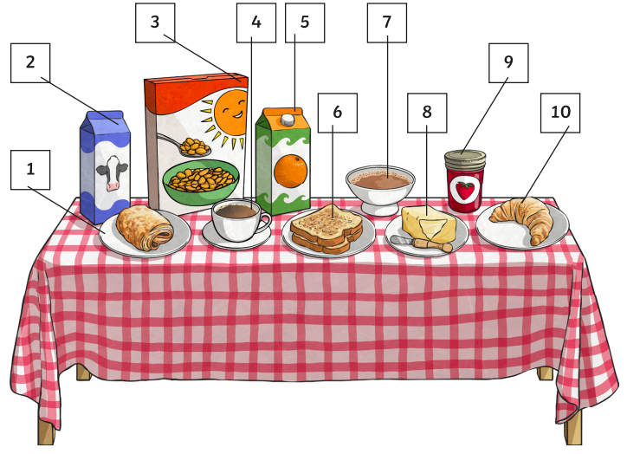

Write the name of each breakfast item in French. You may be able to do this by memory. If not, use the vocabulary sheet on the next page to help you. You can also check your answer after using the vocabulary sheet.

1 |  | 6
2 |  | 7
3 |  | 8
4 |  | 9
5 |  | 10
Vocabulary sheet

