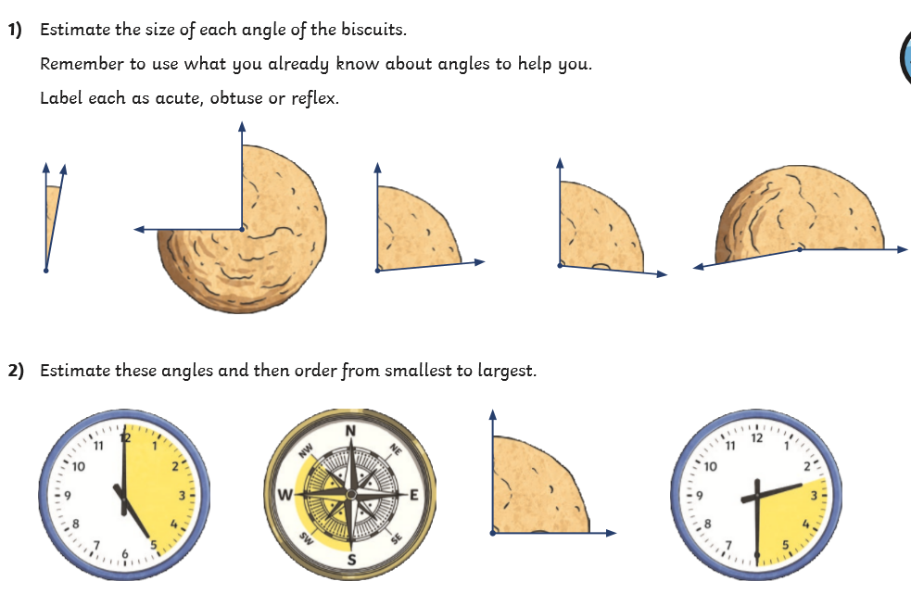
Day 4 estimating and comparing angles today you will be continuing to estimate and compare angles, don’t worry of you don’t have a protractor – you won’t need it! We would like you to try them all, good luck!

