

Cypress Primary Parents’ Guide to
‘Building Learning Power’

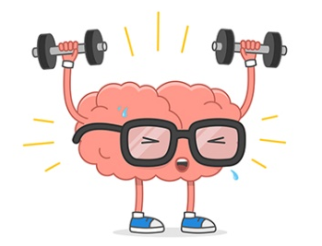
‘Helping young people become better learners’

‘Term on term, year on year, a BLP school breeds young people who are
more curious, more willing to take a risk and give it a go, more imaginative, more creative, more thoughtful, more ready, willing and able to learn with and through others. It’s developing this adventurous spirit that counts’
-Professor Guy Claxton, originator of BLP

What is Learning Power?

Building Learning Power (BLP) is an approach to learning that we have begun to implement at Cypress Primary, Upper School. This approach was created by Professor Guy Claxton. It is based on the idea that we are all capable of becoming better learners. BLP applies this idea directly to the work of teachers in the classrooms, to provide a practical framework for fostering lifelong learning in all young people.


At the Upper School, our school ethos is one of striving to be the best we can be, recognising that we are uniquely different and have varying strengths and interests. BLP allows us to nurture this ethos and build the children’s learning power through a variety of strategies and techniques.
Key Principles

- It is a learning culture that encourages children and teachers to become better learners
- It allows children to approach difficulties in learning without fear of failure
- It allows the children to take small steps within learning
- It develops confidence
- It is not additional to teaching but should be grounded within everyday teaching and learning
- It gives clear labels for the children to use to develop understanding of learning processes

Why are we Building Learning Power?

We believe that BLP is beginning to allow us to develop a common language for learning across the school. The language is used in all classrooms, with all children. This helps everyone talk about understanding learning to learn. We hope that this understanding will begin to spill over into life outside school, where you will be able to reinforce the ideas by encouraging the children to use their learning language in their everyday lives.

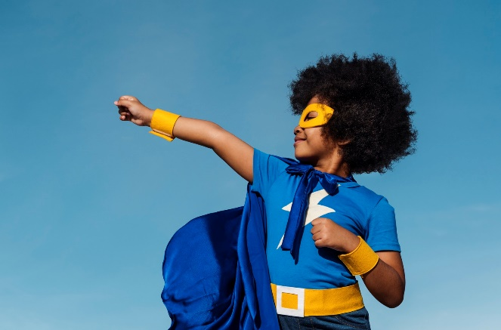
The idea is that the four dispositions (4 Rs) are like a group of "learning muscles". Just as we can build our physical muscles with the right kind of exercise, learning muscles can also be developed and can grow in strength and stamina. It is these we are aiming to develop in the children.

What does BLP look like?

You may have heard your children already using some of the language that has been introduced in school. Professor Claxton suggests there are four main learning dispositions:

- Resilience: not giving up

- Resourcefulness: being able to use a range of learning strategies and knowing what to do when you get stuck,

- Reflectiveness: being able to think about yourself as a learner and how you might be able to do this better,

- Reciprocity: being able to learn with and from others, as well as on your own.

These dispositions are then split into seventeen learning ‘muscles’ that the children are encouraged to ‘stretch’ within their everyday lessons and activities and apply to different aspects of their learning.
Resilience
The resilience muscle is made up of:
Managing distractions  Recognising and reducing distractions; knowing when to walk away and refresh yourself; creating your own best environment for learning. | 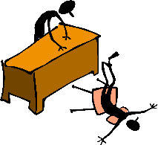
Absorption  Being able to lose yourself in learning – becoming absorbed in what you are doing; rapt and attentive, in a state of ‘flow’. | 
Noticing  Perceiving subtle nuances, patterns and details in experience. | 
Perseverance  Keeping going in the face of difficulties; channelling the energy and frustration positively, knowing what a slow and uncertain process learning often is. | 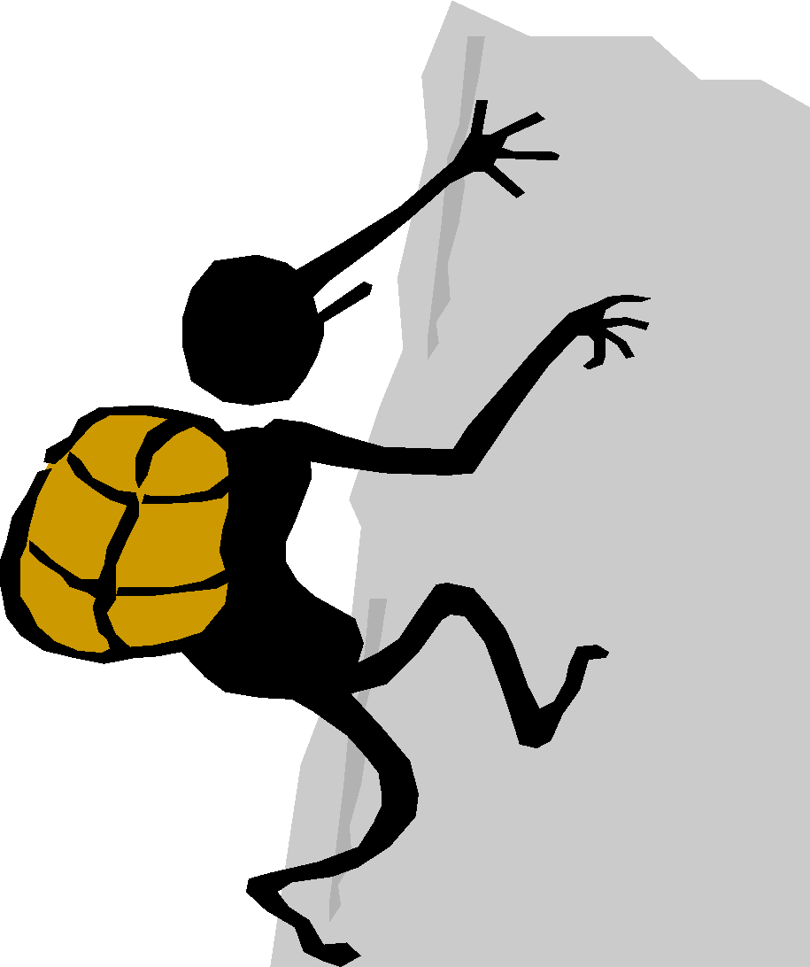
Resourcefulness
The resourceful muscle is made up of:
Questioning  Asking questions of yourself and others; being curious and playful with ideas, delving beneath the surface of things. | 
Making Links  Seeing connections between events and experiences. Building patters – weaving a web of understanding. | 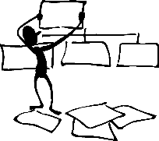
Imagining  Using your imagination and intuition to put yourself through new experiences or to explore possibilities, wondering, ‘What if…?’. | 
Reasoning  Calling up your logical and rational skills to work out methodically and rigorously, constructing good arguments and spotting the flaws in others. | 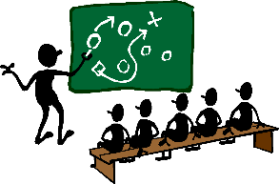
Capitalising  Drawing on the full range of resources from the wider world – other people, books, the internet, past experience and future opportunities | 

Reflectiveness
The reflective muscle is made up of:
Planning  Thinking about where you are going, the action you are going to take and the time and resources you will need and the obstacles you may encounter | 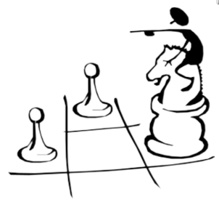
Revising  Being flexible, changing your plans in the light of different circumstances, monitoring and reviewing how things are going and seeing new opportunities. | 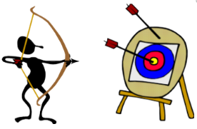
Distilling  Drawing out the lesson from experience, reflecting on the learning and being your own coach. | 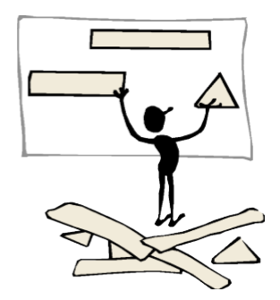
Meta Learning  Knowing yourself as a learner – how to learn best and how to talk about the learning process. | 
Reciprocity
The Reciprocal muscle is made up of:

Collaboration  Knowing how to manage yourself in the give and take of a collaborative venture; respecting and recognising other viewpoints; adding to and drawing from the strength of teams. | 
Imitation  Constructively adopting methods, habits or values from other people whom you observe. | 
Empathy and Listening  Contributing to others’ experiences by listening to them to understand what they are really saying and putting yourself in their shoes; responding thoughtfully to others. | 
Interdependence  Knowing when it’s appropriate to learn on your own or with others, and being able to stand your ground in a debate. | 

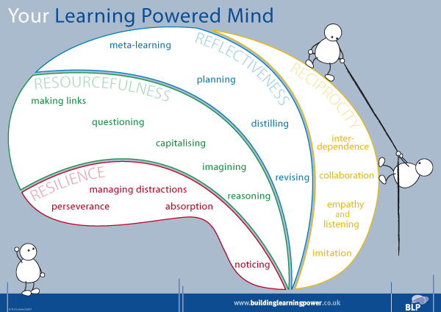

How can you help at home?

Draw attention to, and model positive learning habits
Resilience | - Demonstrate sticking at things even if they are difficult  - Talk about how you feel when you are taking on challenges  - Praise your child when they persevere but also encourage them to take a break when they have had enough  - Help them to find interest and activities that are really absorbing  - Talk with them about what helped them to concentrate and manage distractions
Resourcefulness | - Encourage questions  - Demonstrate making links between different ideas  - Encourage imaginative play  - Model and help them to use resources such as reference books, dictionaries, the internet
Reflectiveness | - Encourage your child to take responsibility for preparing for school  - Do not ask what they did at school, but rather what they learned  - Help them to think about and plan activities  - Encourage flexibility and the ability to change a plan if necessary
Reciprocity | - Demonstrate/model being a good learner  - Work, play and learn alongside your children, enabling them to pick up good habits through imitation  - Make expectations of turn-taking and cooperation clear

