https://www.youtube.com/watch?v=ls5J7caQj7A
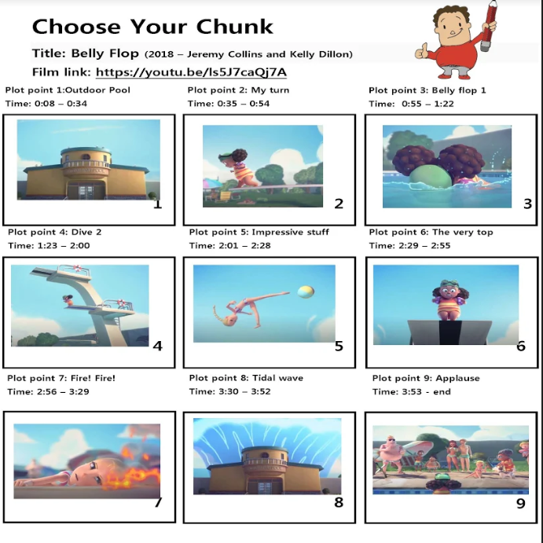
Choose Your Chunk plot points
Plot point 1: Outdoor Pool
Time: 0:08 – 0:34
Plot point 2: My turn
Time: 0:35 – 0:54
Plot point 3: Belly flop 1
Time: 0:55 – 1:22
Plot point 4: Dive 2
Time: 1:23 – 2:00
Plot point 5: Impressive stuff
Time: 2:01 – 2:28
Plot point 6: The very top
Time: 2:29 – 2:55
Plot point 7: Fire! Fire!
Time: 2:56 – 3:29
Plot point 8: Tidal wave
Time: 3:30 – 3:52
Plot point 9: Applause
Time: 3:53 – end
Belly Flop' is a heart-warming animated short film about Penny, a fearless young girl learning to dive, unperturbed by a talented diver who keeps stealing the spotlight.

Examples of Writing in Third Person.
Writing in third person is writing from the third-person point of view, or outsider looking in, and uses pronouns like he, she, it, or they.
It differs from the first person, which uses pronouns such as I and me, and from the second person, which uses pronouns such as you and yours
Tips for Writing in Third-Person Point of View
If you’re writing a novel or a short story, there are advantages to using third-person to take the reader on a narrative journey. If you’ve chosen to write in this POV, follow these eight tips to strengthen your third-person writing skills:
- Do you want your reader to be in suspense?
- Use third-person pronouns. Make sure to be consistent in your use of third-person pronouns such as “he,” “she,” “it,” or “they” when not referring to characters by name.
- Switch viewpoint characters strategically.
- But be sure to avoid head-hopping—i.e. randomly jumping from character to character.
- Choose your viewpoint character carefully.
- Avoid slipping into first-person POV.

The fire grew…it flickered as it danced along Lilly’s perfect plat, the fire grew … blazed burning out of control, the fire grew …raging around the sunbathing area of the lido.

