Celebrating Black History, Celebrating Lives Assembly 12 & 15.10.2020
Can you name these people who made our world great?
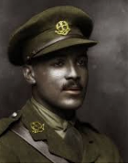 | 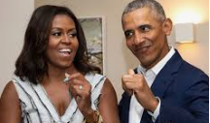 | 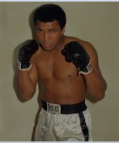 | 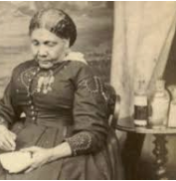
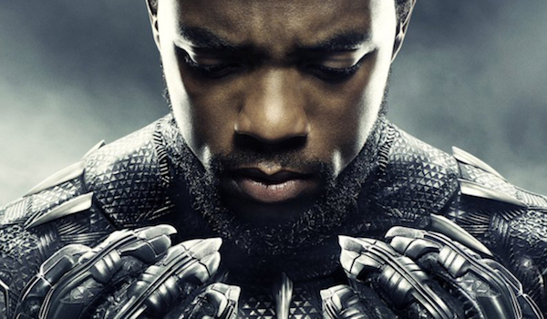 | 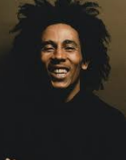 | 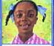 | 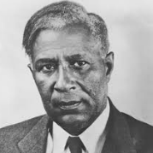
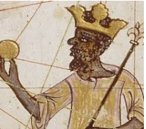 | 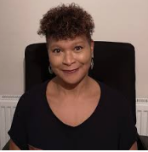 | 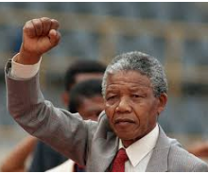 | 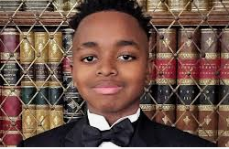
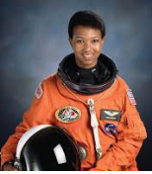 | 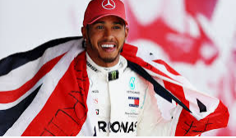 | 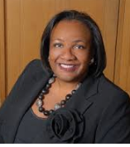 | 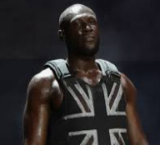
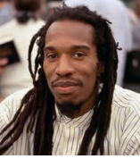 |  | 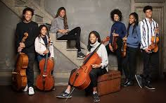 | 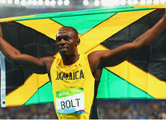
Celebrating History, Celebrating Lives Answer sheet
Walter Tull, World War One British Army Officer and Tottenhan Hotspur football player https://www.youtube.com/watch?v=KTpQb-Q4Y4I
Michelle and Barack Obama, The former First Lady and President of the USA https://www.youtube.com/watch?v=-EUbjOtRGaY
Muhammad Ali, The Greatest boxer of all time, activist, spokesperson and philanthropist https://www.youtube.com/watch?v=J9CeC3yrcG4
Mary Seacole, A natural herbalist and pioneering nurse of the Crimean War https://www.youtube.com/watch?v=u5pSbe-9bNQ https://www.youtube.com/watch?v=_4FYMIG2TKY
Black Panther/Chadwick Boseman Actor https://www.youtube.com/watch?v=xjDjIWPwcPU
Bob Marley Singer, songwriter, and musician. A Rastafarian reggae icon ‘Don’t Worry About a Thing’ https://www.youtube.com/watch?v=wYCpWblDKok
Amazing Grace Story https://www.youtube.com/watch?v=GArzTjbS2ls
Garret Morgan, Inventor of the modern three-way traffic lighthttps://www.youtube.com/watch?v=iDwAulTzENQ
King Mansa Musa, The Richest man who ever lived https://www.youtube.com/watch?v=O3YJMaL55TM
Trish Cooke Author ‘So Much’ https://www.youtube.com/watch?v=o964_7P2Ur4
Nelson Mandela Former President of South Africa https://www.youtube.com/watch?v=q_yA2ZkS-PA
Joshua Beckford, 6 year old Oxford Graduate https://www.youtube.com/watch?v=NrSSoYAlaEo
Mae Jemison Astronaut https://www.youtube.com/watch?v=JZoDnBoTTxQ
Lewis Hamilton Racing Car Champion https://www.youtube.com/watch?v=Kl-pmHCnvy8
Diane Abbott, the longest-serving black, female Member of Parliament in the House of Commons https://www.youtube.com/watch?v=2aROXGhM7N8
Stormzy Rapper, song writer, philanthropist https://www.youtube.com/watch?v=q-EW4-B11hw
Benjamin Zephaniah Poet ‘People Need People’ https://www.youtube.com/watch?v=8uHHjAsPbLc
Jo Jo and Gran Gran Cartoon https://www.youtube.com/watch?v=BEqo6ZJrazM&list=RDBEqo6ZJrazM&start_radio=1
The Kanneh-Mason Family Classical musicians https://www.youtube.com/watch?v=J4s_4nKx-CY
Usain Bolt The greatest sprinter in the world https://www.youtube.com/watch?v=FuiJHJz4f5Q

