Year 6 maths investigation w/c 20/4/20
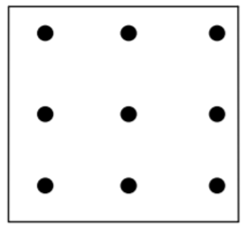
The nine ‘dots’ above are known as a geoboard. They are usually pegs on a wooden board that you can stretch rubber bands around. For this investigation however you can use the ‘dotty’ paper or draw your own 3 x 3 geoboards.
Challenge 1: How many different triangles can you make using the geo board? They can be any size or orientation (any way round) but they must be different (i.e. not just rotated or reflected!).
Challenge 2: Can you classify all the different triangles you have made (remember, a right angled triangle can always be classified as a different type of triangle too).

Challenge 3: Can you calculate the areas of all your triangles?
The formula for the area of a triangle = half the base x perpendicular height.
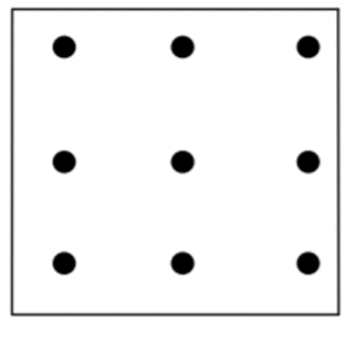
If we say the ‘gap’ between two dots equals 1 unit, then the base of this triangle is 1 unit and its perpendicular (‘straight up’) height is 2 units.
So its area is half the base (1/2) x perpendicular height (2)
½ x 2 = 1 unit²
Good luck and let us know how you get on by commenting on your class blog!
