WALT plan and organise a non-chronological text
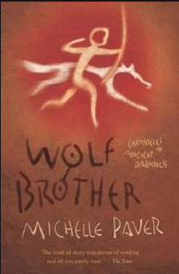
- Re-read your facts from yesterday about your chosen clan animal.

- Create an interesting title for your fact file.

- Create 5 or 6 relevant subtitles for the facts you have found. Examples could include: Appearance, Habitats, Food and Hunting and Other Interesting Facts.

- Copy and paste or re-write on paper your facts into the appropriate section.

- Research and add extra detail to any sections which lack information.

Fact File Title:

Subtitle:

Facts:

Subtitle:

Facts:

Subtitle:

Facts:

Subtitle:

Facts:

Subtitle:

Facts:

Subtitle:

Facts:

Subtitle:

Facts:

